Alexander Cannell

2/13/12

Professor Robertson

Chapter 5

Project 5-1:

What I did is hooked up the lab computer up to a switch, and everyone else in the class hooked up to the same switch. We were able to ping our computer, and other computers, our ip was 192.168.

What we learned is how to connect and set up to a simple star network, and to communicate with each of the nodes/clients on the network.

How this applies to a networking professional is networking professionals will need to learn how to set up a simple network, understand, and work with the same network.

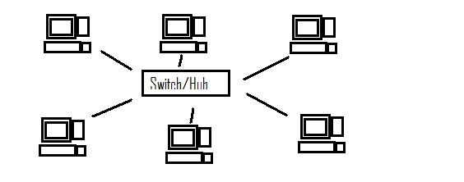

Project 5-2:

I start this project by installing wireshark, and winPcap.

Then I started up wireshark, and started to capture stuff on my network.

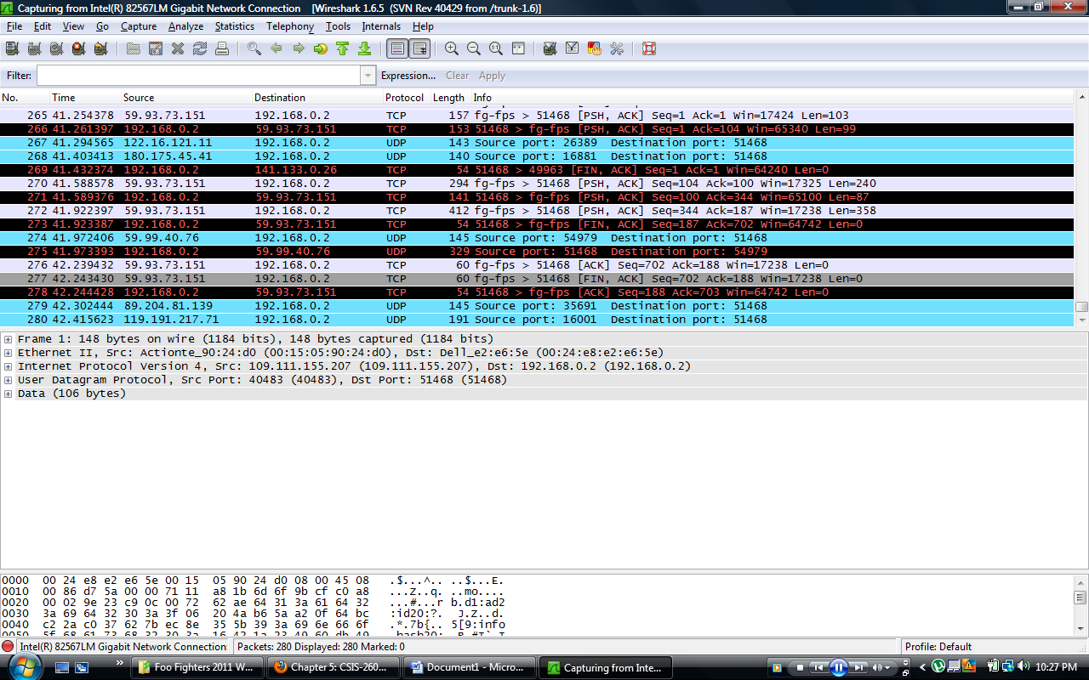

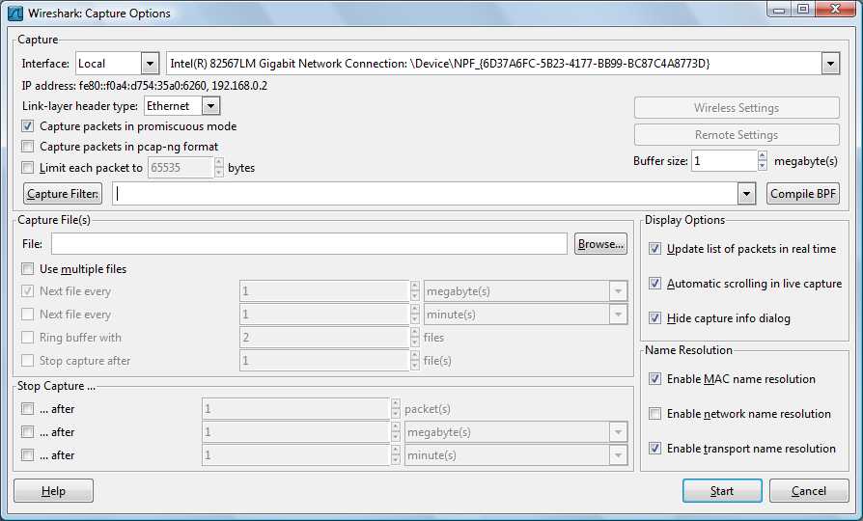

My Nic is a intel r 82567lm gigabit network connection, and my Ip address is 192.168.1.2.

The traffic I see most on my network is tcp, and udp. Occasionally arp, who says, “who is this ip”.

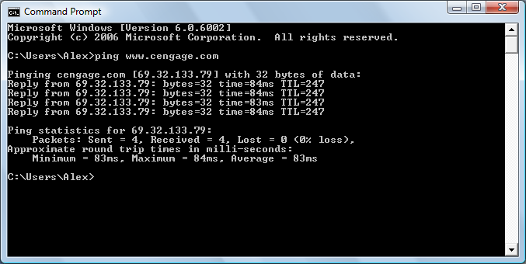

I pinged [www.cengage.com](http://www.cengage.com) and looked at wireshark’s reaction to my ping. Which came up with mostly blue reactions, and a little green http part.

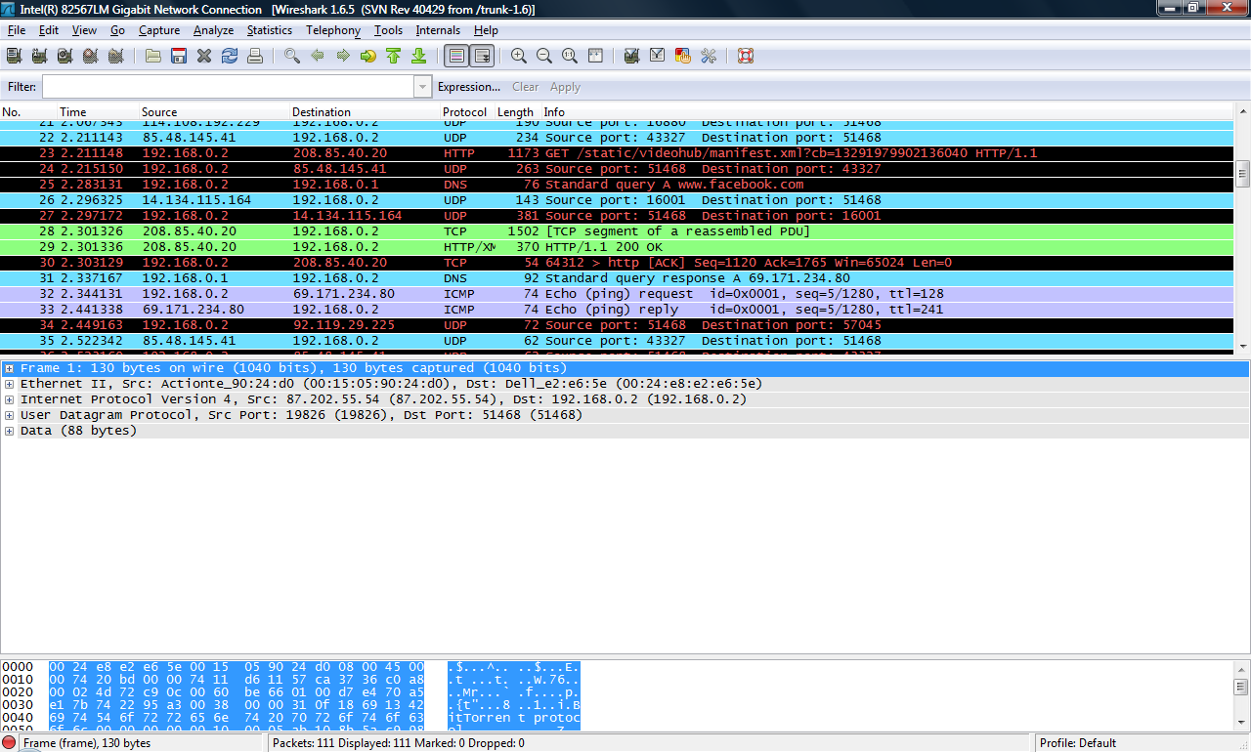

I found only one http packet and a lot of tcp.

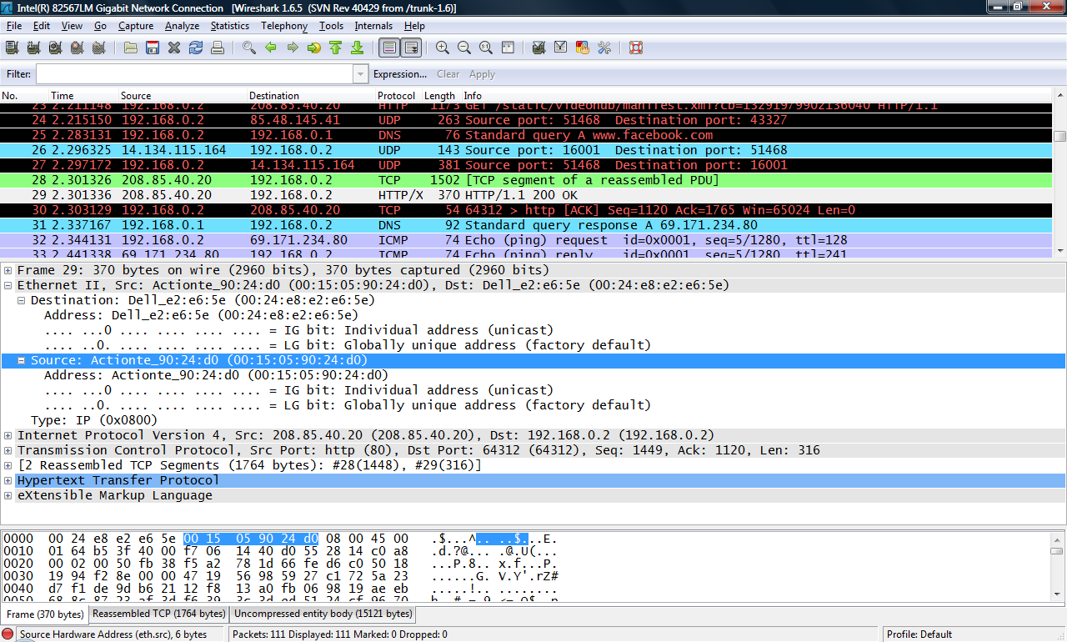

Clicking on me the http packet line you can see the Ethernet 2 line and info, which contains the router and mac addresses of my router and my computer.

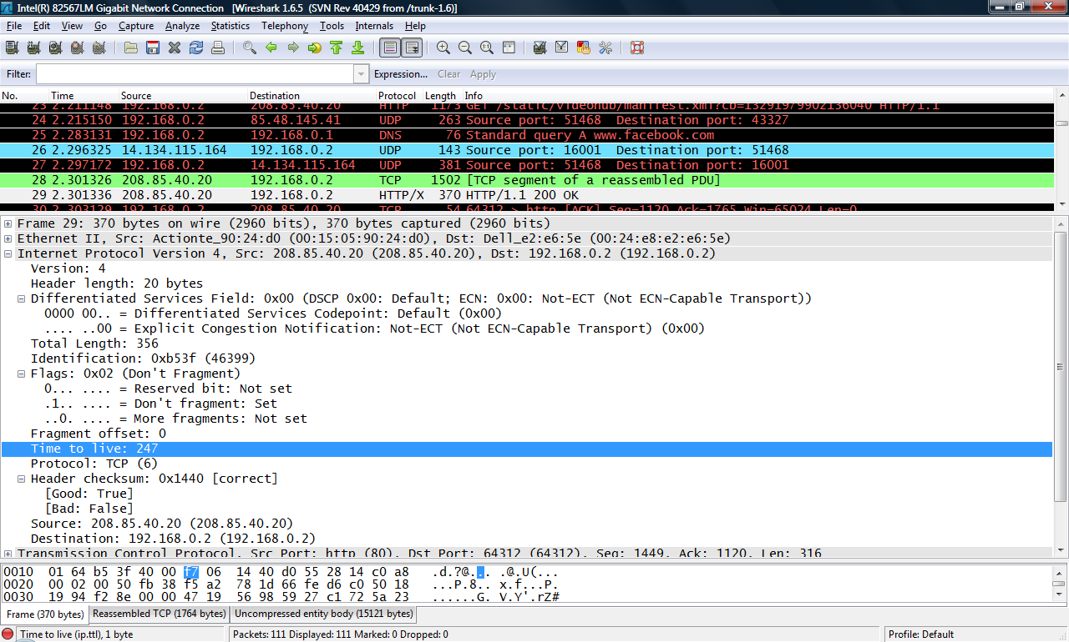

This is showing the internet protocol(IP) mine is a verson 4. the source = 208.85.40.20 and destination = 192.168.0.1. Header length is 20 bytes.

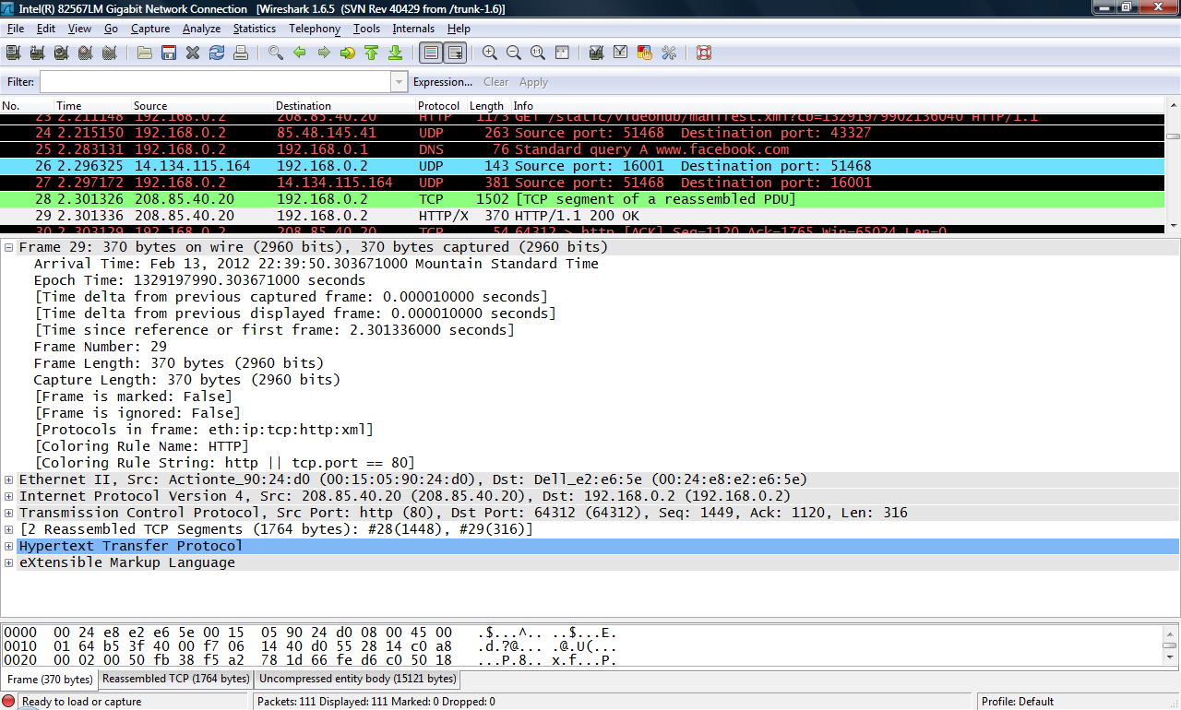

Frame Number: 29, Frame Length: 370 bytes.

Project 5-3:

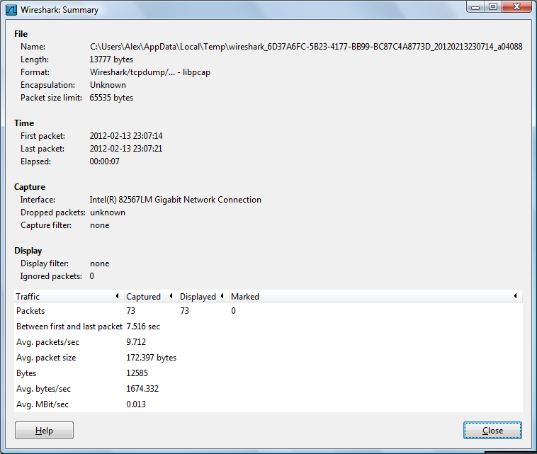

Packets = 73, Avg.packet size = 172.397 bytes.

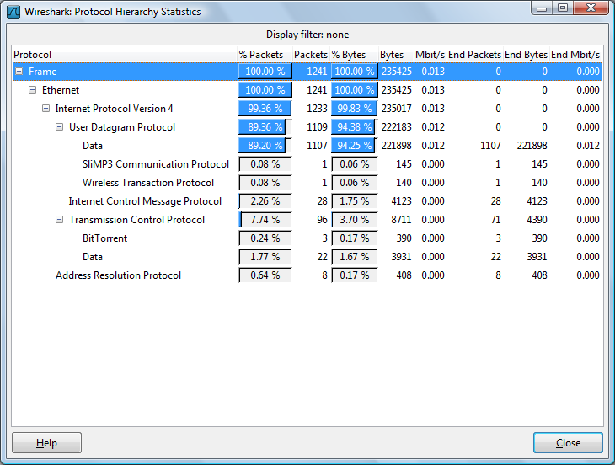

Ethernet frame is 100.0%, Internet protocol version 4 is 99.36%, Internet control message protocol 7.74%.

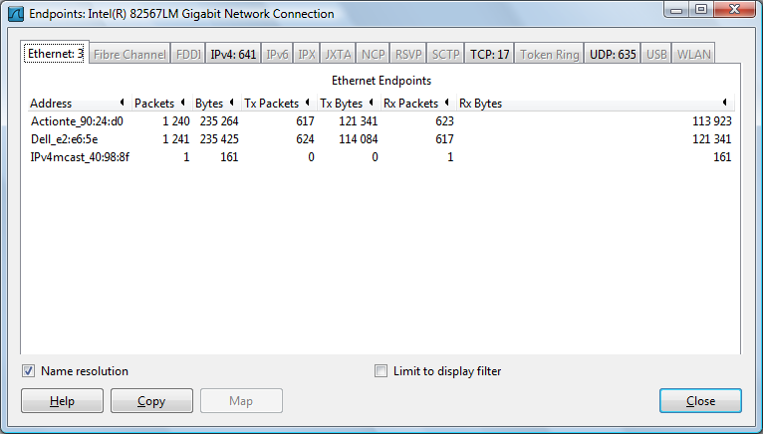

Action tech is the node at the top of the list. And the dell and ipv4 are next.

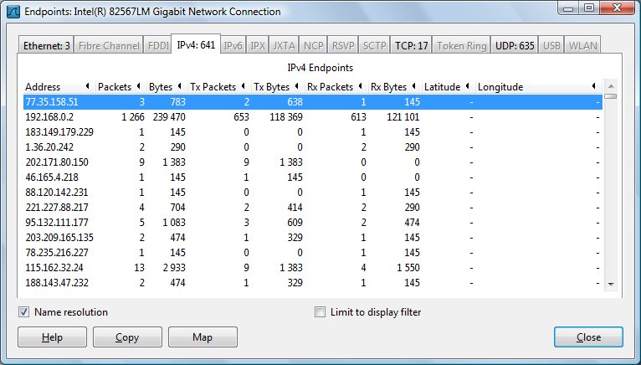

77.35.158.51 is the top IP address.

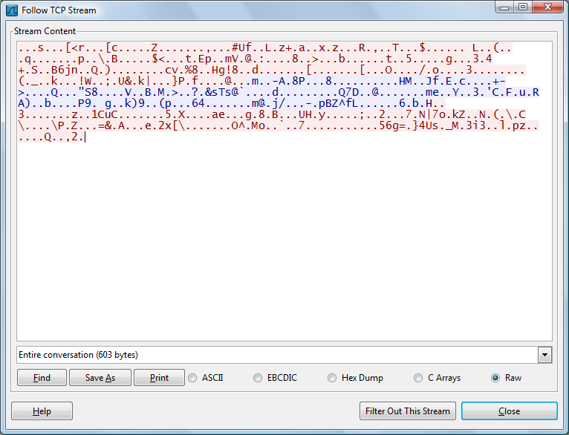

I followed the TCP Stream, this shows the stream of one TCP Packet.

Then I closed WireShark